**You will need to create an AWS account if you don't already have one**

**To create an AWS account**

1. Open <http://aws.amazon.com/>, and then choose **Create an AWS Account**.

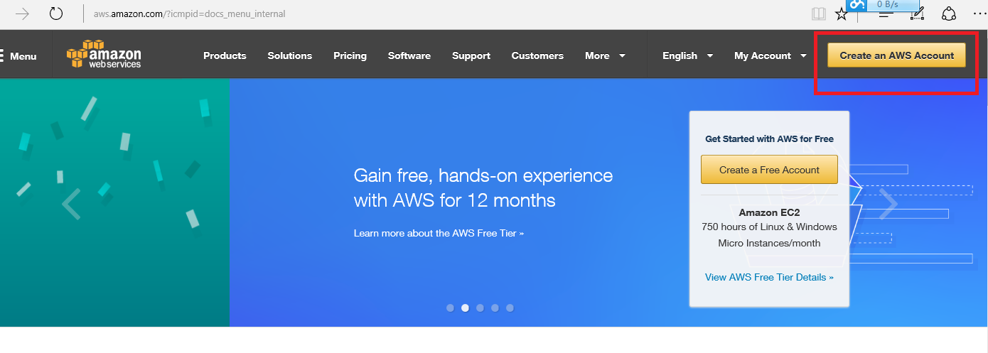

1. Follow the online instructions.

Part of the sign-up procedure involves receiving a phone call and entering a PIN using the phone keypad.

Firstly, input your email and select “I am a new user” to.

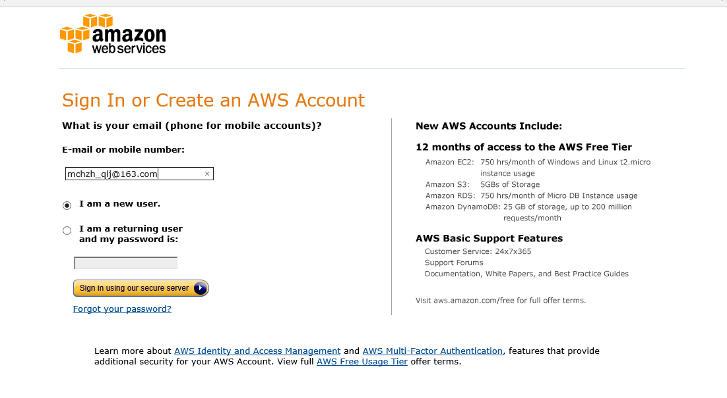

Click “Sign in using our secure server”

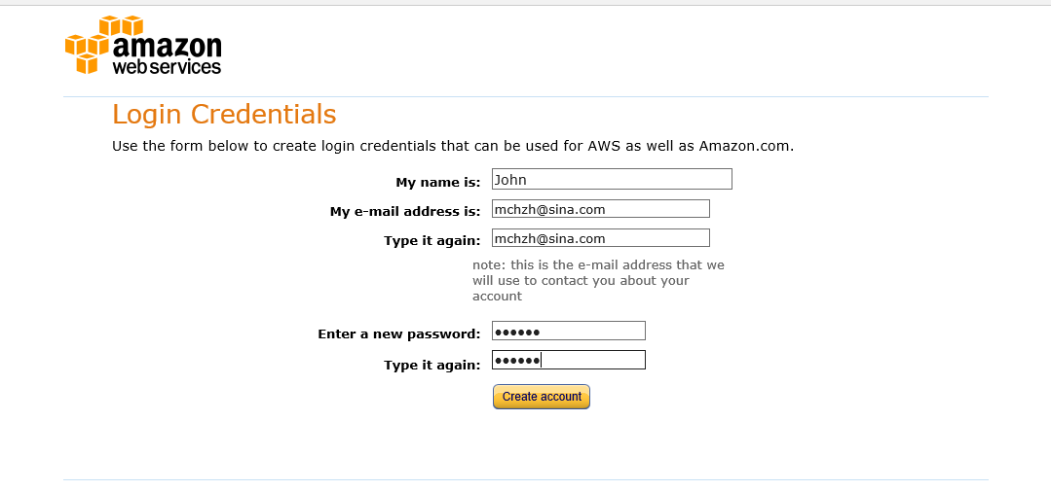

Set your password and make sure your email once again. Click “Create account”

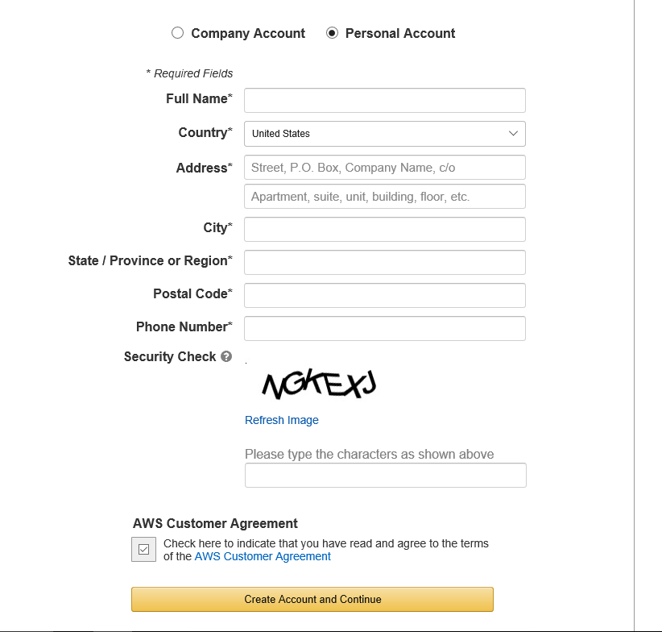

Input your company or personal info, to click “Create Account and Continue”

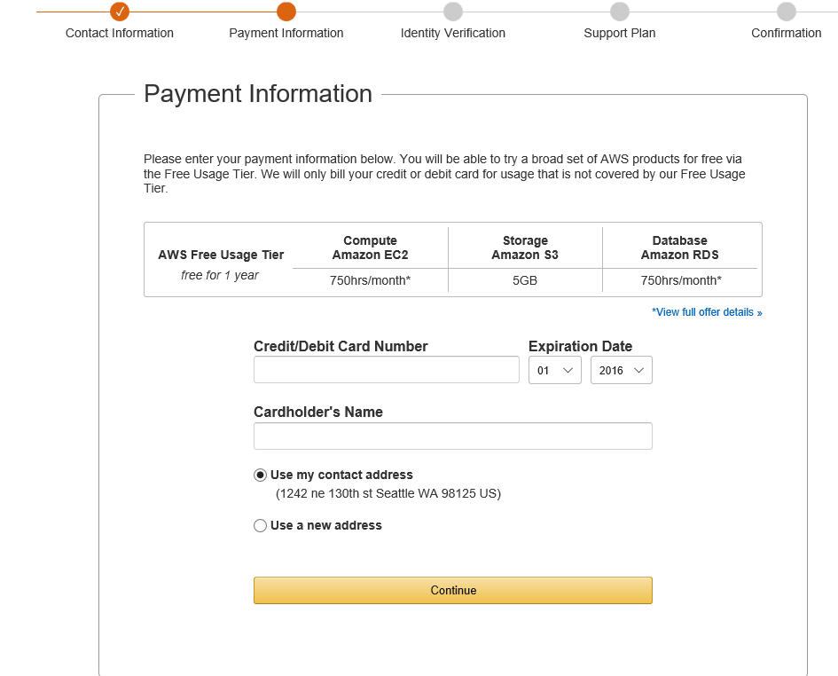

Input the payment information then click “Continue”

Note: Click “*view full offer details” then go to page -- <https://aws.amazon.com/free/>

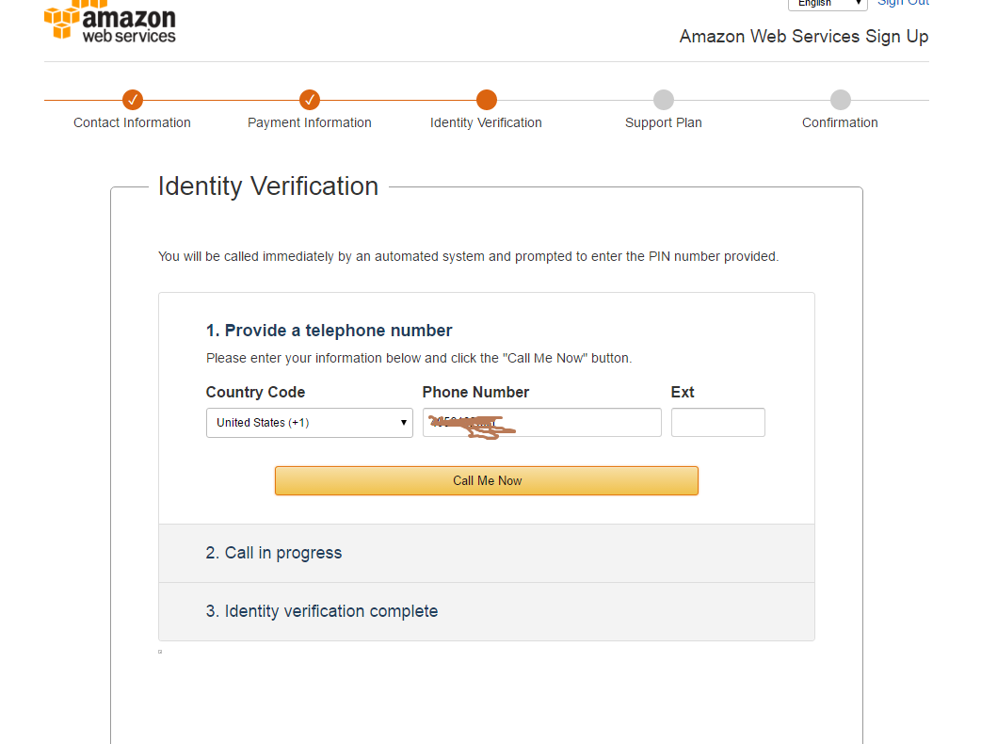

After click call me now, the process will go to 2 call in progress. In this time, you will receive a phone call from Amazon. It requires you in cell phone to input your 4 digits PIN displayed in the computer. And then verification finished

After PIN response, in the 3 step to see Identity verification complete, click “Continue to select your Support Plan”.

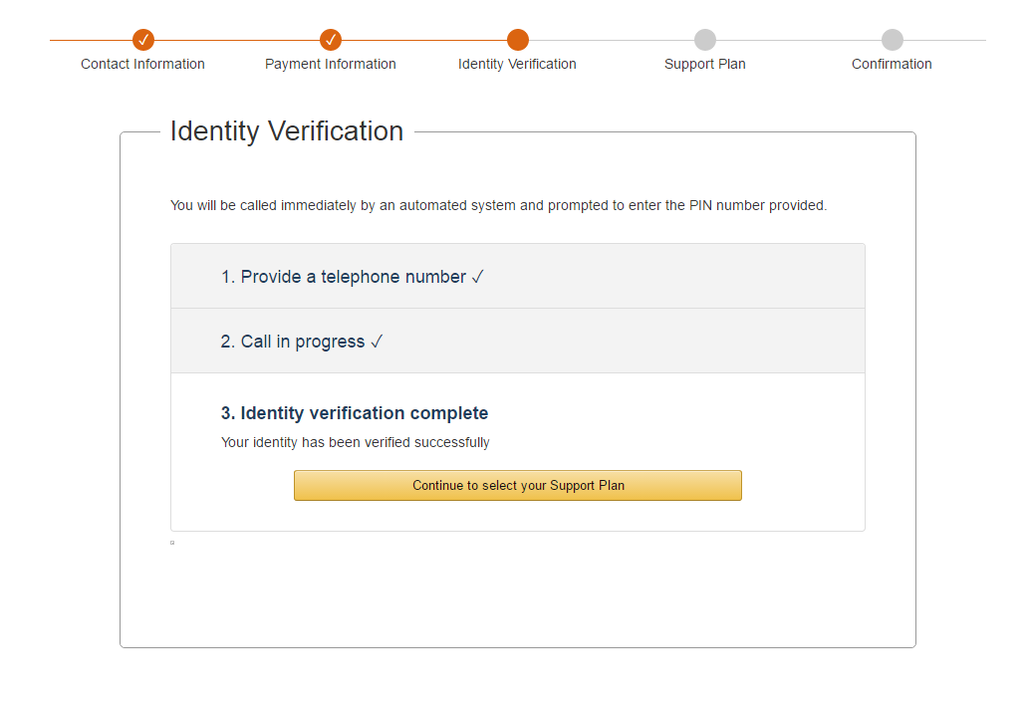

In support plan page select any plan you wanted, commonly use “Basic(Free)” option

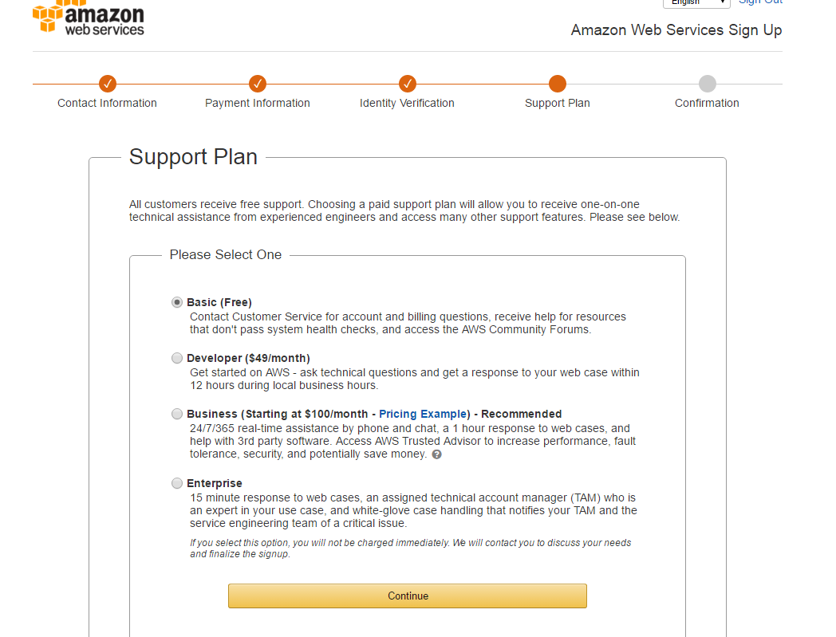

Click “continue” to complete the creation of an AWS account

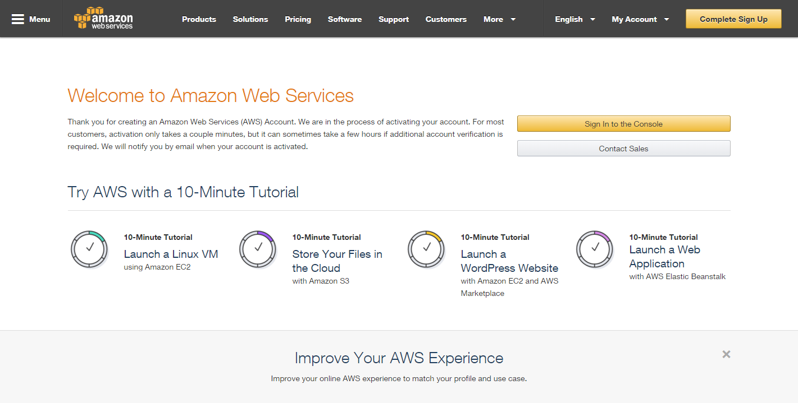

Then you can use your email to login in AWS console

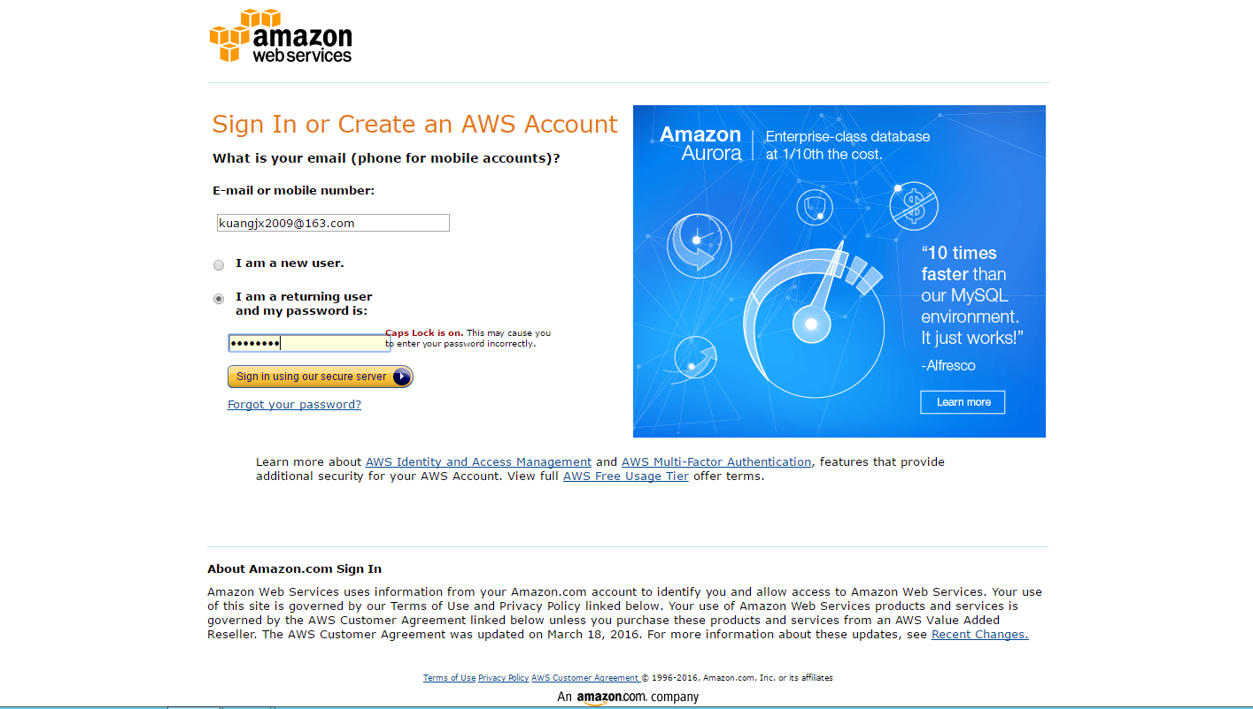

The main service page is like:

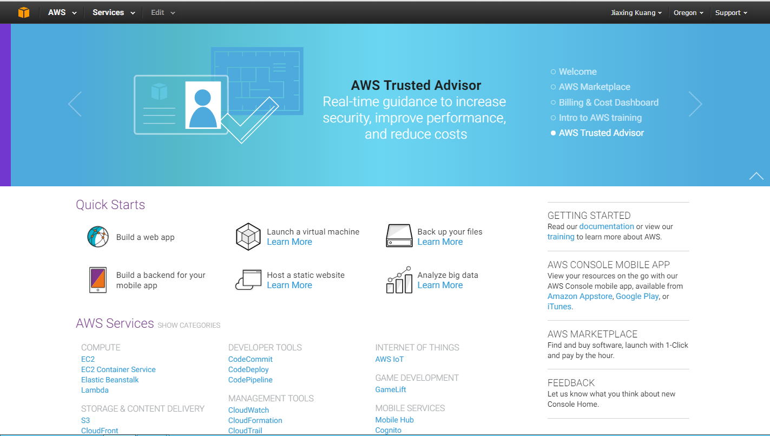

It shows your AWS service can work.

Note your AWS account ID, because you'll need it for the next task.